## OOP Assignment

## Messaging App:

This is how the messaging app works:

The menu is shown on the screen from where the user can choose to:

1. Send Message

2. Display Messages

3. Delete Message

4. Check Message Status

5. Search Message

6. Exit

1. **Send Message:**
   * The user can enter the **sender's name**, the **receiver's name**, and the **message content**.
   * The app stores each message in a 2D array. The sender and receiver are stored in specific slots.
   * The user can keep sending multiple messages if they choose to.
2. **Display Messages:**
   * The app displays all the stored messages.
   * Each message shows the sender, receiver, and the content of the message.
   * The messages are sorted by **timestamp** (the time they were sent), so the most recent ones appear last.
3. **Delete Message:**
   * The user can delete a message by specifying the **sender's name** and the **receiver's name**.
   * The app finds the message and deletes it from the storage.
4. **Check Message Status:**
   * This feature shows if a message has been **seen** or **unseen** by the receiver.
   * The app goes through all messages to find the ones that haven't been seen yet.
5. **Search Message:**
   * The user can search for a message by providing the **sender's** and **receiver's names**.
   * The app finds and displays the message, showing details like the message content and timestamp.

**Structure:**

* Messages are stored in a **2D array** where each row and column represent different senders and receivers.
* The app provides a simple **menu** to interact with these features.

Here’s a simple demonstration of its working:

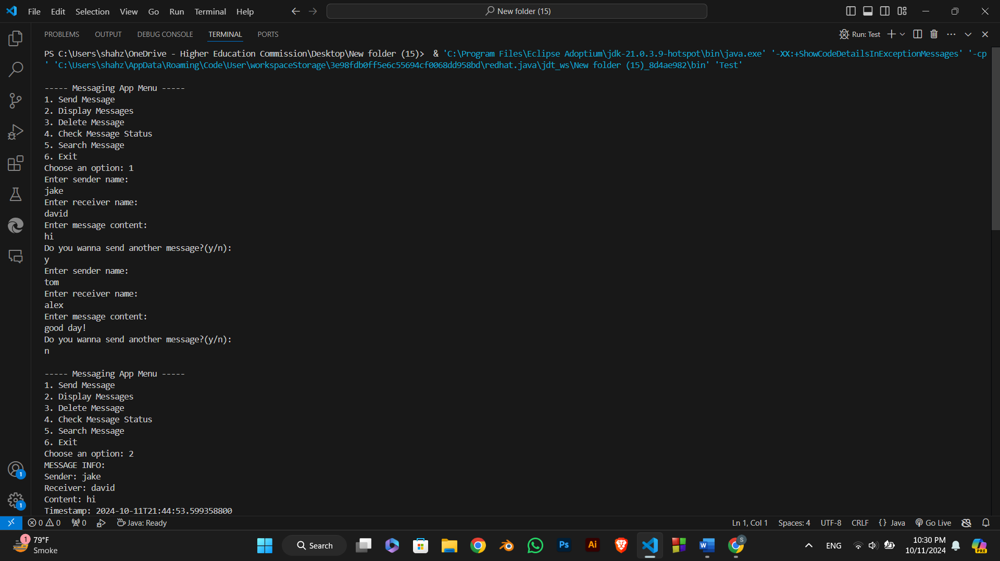

Submitted By: Samra Alam (sp24-bse-137-B)

Submitted To: Muhammad Shahid Bhatti